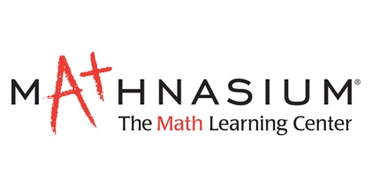
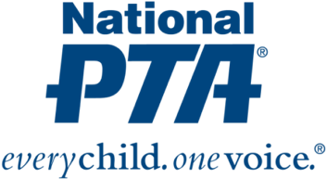

Mathnasium Partners with National PTA on STEM Initiative

Mathnasium of Powell is one of 680 Mathnasium locations nationwide slated to put the “M” in STEM

Powell, Oh, (June 21, 2016)—Mathnasium Learning Centers is proud to announce that it has joined forces with National PTA as a partner in PTA’s nationwide science, technology, engineering and math (STEM) education and family engagement initiative. Through this collaboration, Mathnasium will support National PTA in the development and deployment of resources, activities and events that engage students and families in STEM/math experiences.

“Mathnasium is honored to forge an alliance with National PTA,” said Peter Markovitz, founder and chief executive officer of Mathnasium. “As a founding sponsor of PTA's STEM initiative, we're excited for this invaluable opportunity to collaborate with dedicated educators and parent leaders. It heralds a new chapter for our company as we carry out our mission to help every child understand—and master—math.”

“We at Mathnasium of Powell are enthusiastic supporters of community schools and parent leader organizations for the benefit of all students,” added Ravi and Satya, Owners and Center Directors of Mathnasium of Powell. “Math is the foundation for all STEM fields, and we’re eager to explore all the possibilities this partnership offers in the way of making math come alive through inspiring and accessible STEM learning experiences in Olentangy School District.”

Launched in 2015, National PTA’s initiative seeks to fill a critical gap in STEM education, increase access to STEM experiences for all students and inspire the next generation of STEM professionals. Its goal is to deliver 100,000 STEM experiences over the next three years—in schools and at home. The effort will include a focus on urban areas and among girls and underrepresented youth.

“We know—and decades of research proves—that family engagement is essential to children’s achievement. We also know that families play an important role in helping students navigate educational and career decisions and are influencers of students’ perceptions of what’s possible for their futures,” said Nathan R. Monell, CAE, National PTA executive director. “Family engagement is critical to strengthen STEM education, support student success in STEM and inspire children to pursue STEM careers.”

As National PTA expands the STEM initiative, Mathnasium will work alongside education and industry leaders across all STEM disciplines.

“The Mathnasium Method has helped transform the way children understand and appreciate math. Through its personalized programs, Mathnasium seeks to make math fun and to make math make sense for every child,” said Laura Bay, president of National PTA. “We are thrilled to have Mathnasium join our STEM initiative and collaborate to engage families and inspire children’s love of math.”

About Mathnasium
Mathnasium, the nation’s leading math-only learning center franchise, specializes in teaching kids math in a way that makes sense to them. The result of 40+ years of instruction and research, the Mathnasium Method has transformed the way children understand and appreciate math—whether they’re ahead of the curve, performing at grade level, or falling behind. Franchising since 2003, Mathnasium has become one of the fastest-growing educational franchises, with a new center opening each week. There are more than 700 Mathnasium franchises in the U.S. and abroad. For more information, visit http://www.mathnasium.com or call 1-877-601-MATH.

About National PTA
National PTA® comprises millions of families, students, teachers, administrators, and business and community leaders devoted to the educational success of children and the promotion of family engagement in schools. PTA is a registered 501(c) (3) nonprofit association that prides itself on being a powerful voice for all children, a relevant resource for families and communities, and a strong advocate for public education. Membership in PTA is open to anyone who wants to be involved and make a difference for the education, health, and welfare of children and youth.

Media Contact:
Ravi Kopuri, Mathnasium of Powell
(740)236-9100, powell@mathnasium.com
9866 Brewster Ln
Powell, OH 43065

