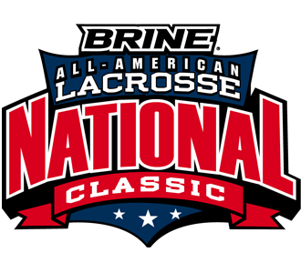

Andrew Wagner Selected to Play in
2016 Brine National Lacrosse Classic

Andrew Wagner, son of Rob and Jodee Wagner, a Senior at Rutherford B. Hayes High School, a member of the Delaware Hayes Varsity Lacrosse team as well as member of BlackJack Elite Lacrosse Club, has been named as a 2016 Brine National All-American and has been selected to represent the State of Ohio at the 2016 Brine National Lacrosse Classic to be held in Richmond, Virginia July 19-22, 2016.

The Brine National Lacrosse Classic brings the top high school lacrosse players in the nation to one venue, where regional teams compete to become the National Champion. The event puts players in front of college lacrosse coaches in a recruiting showcase.

For additional details, visit http://www.nationallacrosseclassic.com

